
Name: ____________________ My Target: _____ / 37 or ____%  

Year 10 History

Key Focus: The Modern World and Australia /37
Source Analysis – Two (5%)

* Complete all questions.
* Remember to refer to the sources within your text.
* Working time 40 minutes; 5 minutes reading time.

Source 1

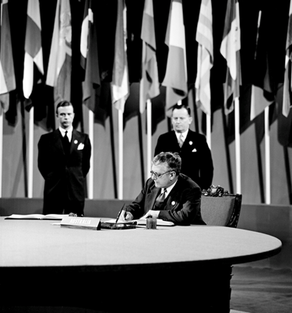

Flags & Badges. The Australian Minister for External Affairst signing the Charter of the United Nations at the San Fancisco Conference, 26 June 1945. The Charter was adopted unanimously on 24 October 1945. This photograph was taken at the San Francisco War Memorial Opera House.

1. Look at Source 1; state the name of the person shown in the photograph.

_____________________________________________ (1 mark)

2. With reference to Source 1 and using your historical knowledge of the period, explain who the person is, what their role was and what their contribution was to the organisation.

___________________________________________________________________________________________________________________________________________________________________________________________________________________________

___________________________________________________________________________________________________________________________________________________________________________________________________________________________

_____________________________________________________________________________________________________________________________________________________________________________________________________________________________________________________________________________________________________________________________________________________________________________

_________________________________________________________________________

(4 marks)

3. Look at Source 1; state the full name of the organisation connected to this photograph.

________________________________________________________________ (2 marks)

4. State the full date (date, month, year) that this organisation was established.

___________________________________________________________ (3 marks)

5. Outline the international organisation represented here.

______________________________________________________________________________________________________________________________________________________________________________________________________________________________________________________________________________________________________________________________________________________________________________________________________________________________________________________

(3 marks)

6. This organisation also produced the UDHR. State what this stands for.

_________________________________________________________________________

_________________________________________________________________(4 marks)

5. Using your historical knowledge, list three of the human rights injustices that occurred during World War Two.

________________________________________

________________________________________

________________________________________ (3 marks)

Source 2

The reputation Dr. Herbett Vere Evatt won for himself as the voice of Australia long endured in the United Nations. It brought great credit to his country; more than any other national leader, Evatt made Australia known universally and made it known as a country of courage, responsibility and liberalism ... Deprived throughout the war of the say to which Evatt thought Australia was entitled, he had his reward at San Francisco, where Australia was heard as never before. What was of more lasting value was that when it was heard, it had something worthwhile to say." The Doc Evatt Foundation. http://evatt.org.au/about-us/doc-evatt.html

Alan Renouf, oral history interview, 23 November 1993,

- State if Source 2 is a primary or secondary source.

_____________________________________________ (1 mark)

- What is the message of Source 2 – explain what the source is trying to get you to

think, believe or feel? Use examples from the source in your response.

______________________________________________________________________________________________________________________________________________________________________________________________________________________________________________________________________________________________________________________________________________________________________________________________________________________________________________________________________________________________________________________________________________________________________________________________________________________________________________________________________________________________________________________________________________________________________________________________________________________________________________________________________________________________________________________________________________

____________________________________________________________________________________________________________________________________________________________________________________________________________________________________________________________________________________________________________________________________________________________________________________________________________________________________ (6 marks)
- Using your historical knowledge, explain one relationship which is apparent between Source 1 and Source 2. (3 marks)

______________________________________________________________________________________________________________________________________________________________________________________________________________________________________________________________________________________________________________________________________________________________________________________________________________________________________________________________________________________________________________________________________________________________________________________________________________________________________________________

4. List three sections, or parts, of the United Nations Organisation.

________________________________________

________________________________________

________________________________________ (3 marks)

5. Explain the Security Council of the United Nations Organisation.

______________________________________________________________________________________________________________________________________________________________________________________________________________________________________________________________________________________________________________________________________________________________________________________________________________________________________________________________________________________________________________________________________________________________________________________________________________________________________________________

(4 marks)

End of paper

